A4018-Asia-China-Shang-Guang-Camel-Muntjak-1722-1100 BCE

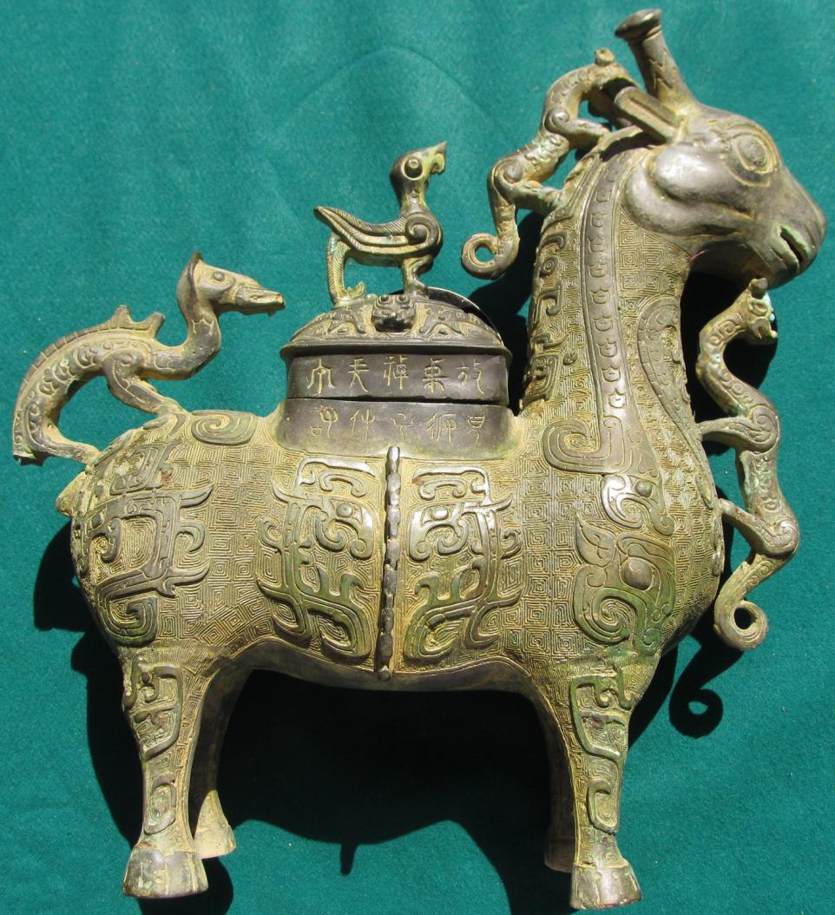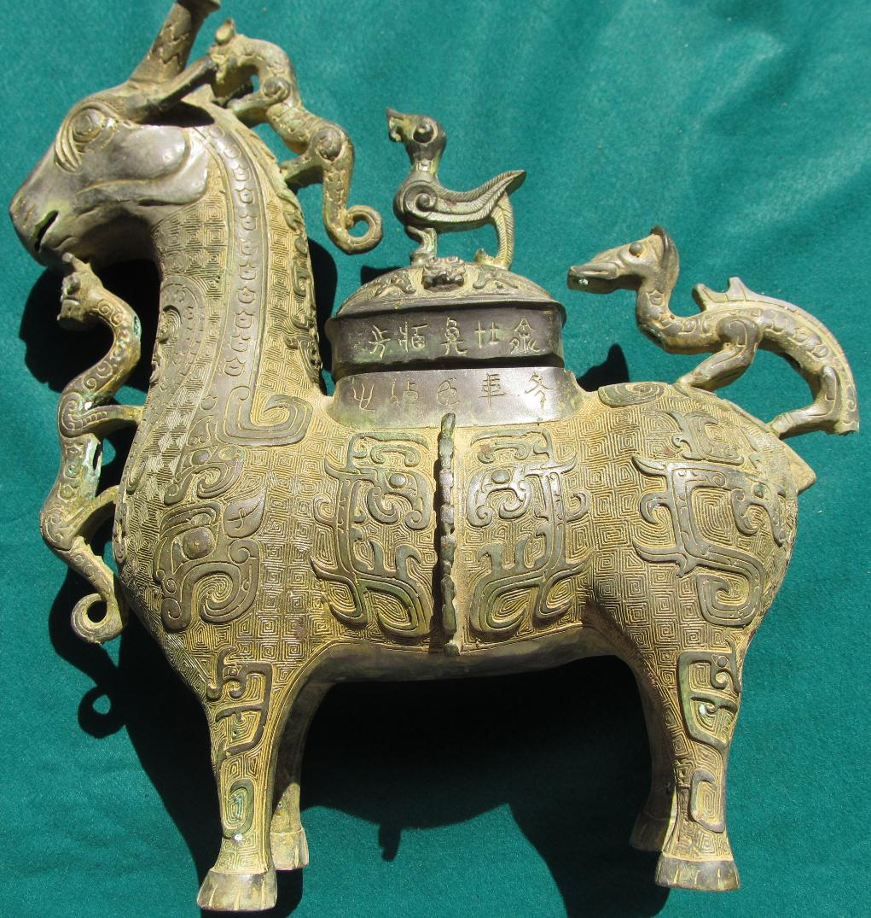

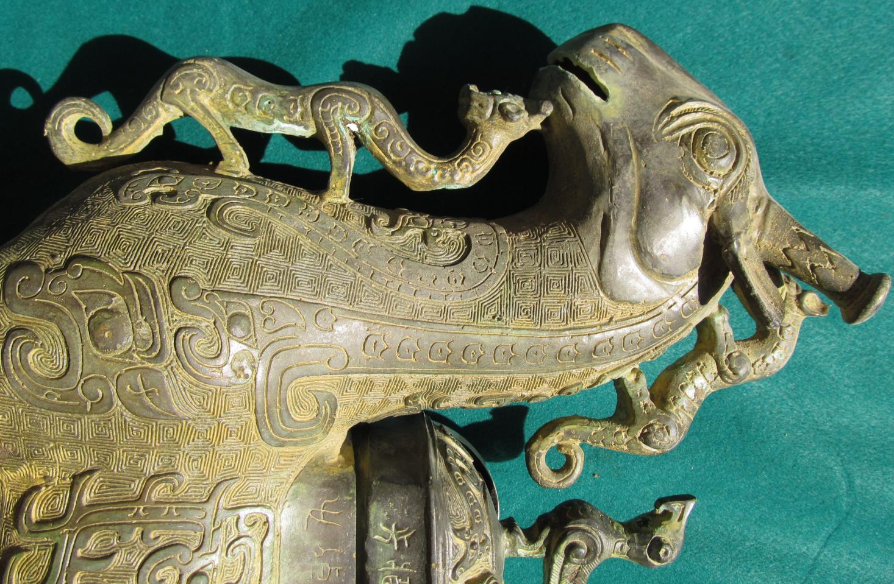

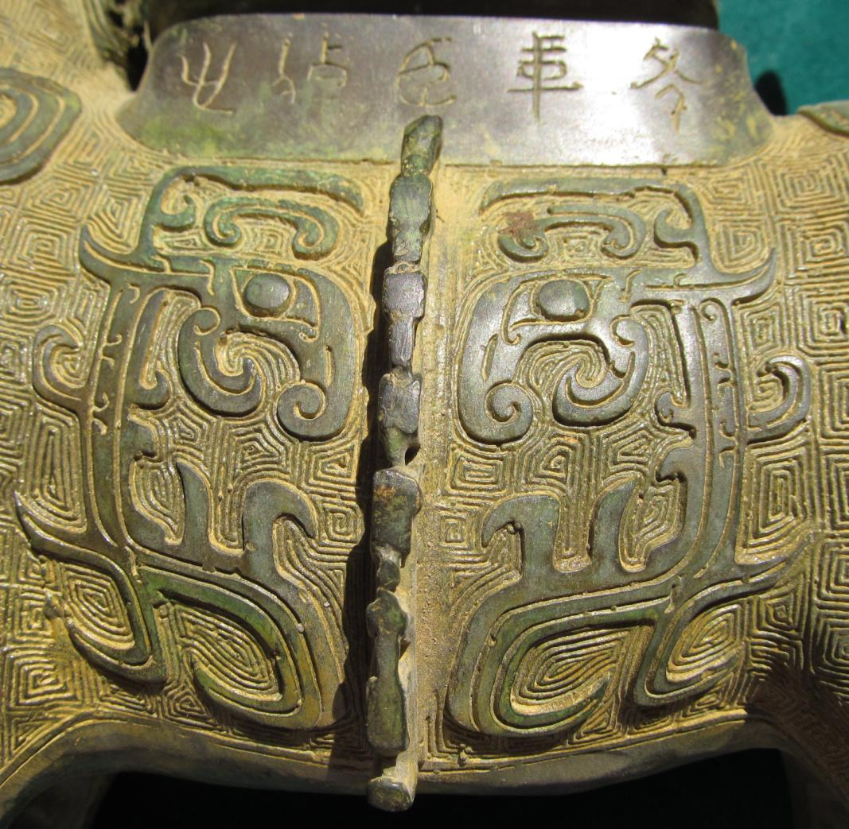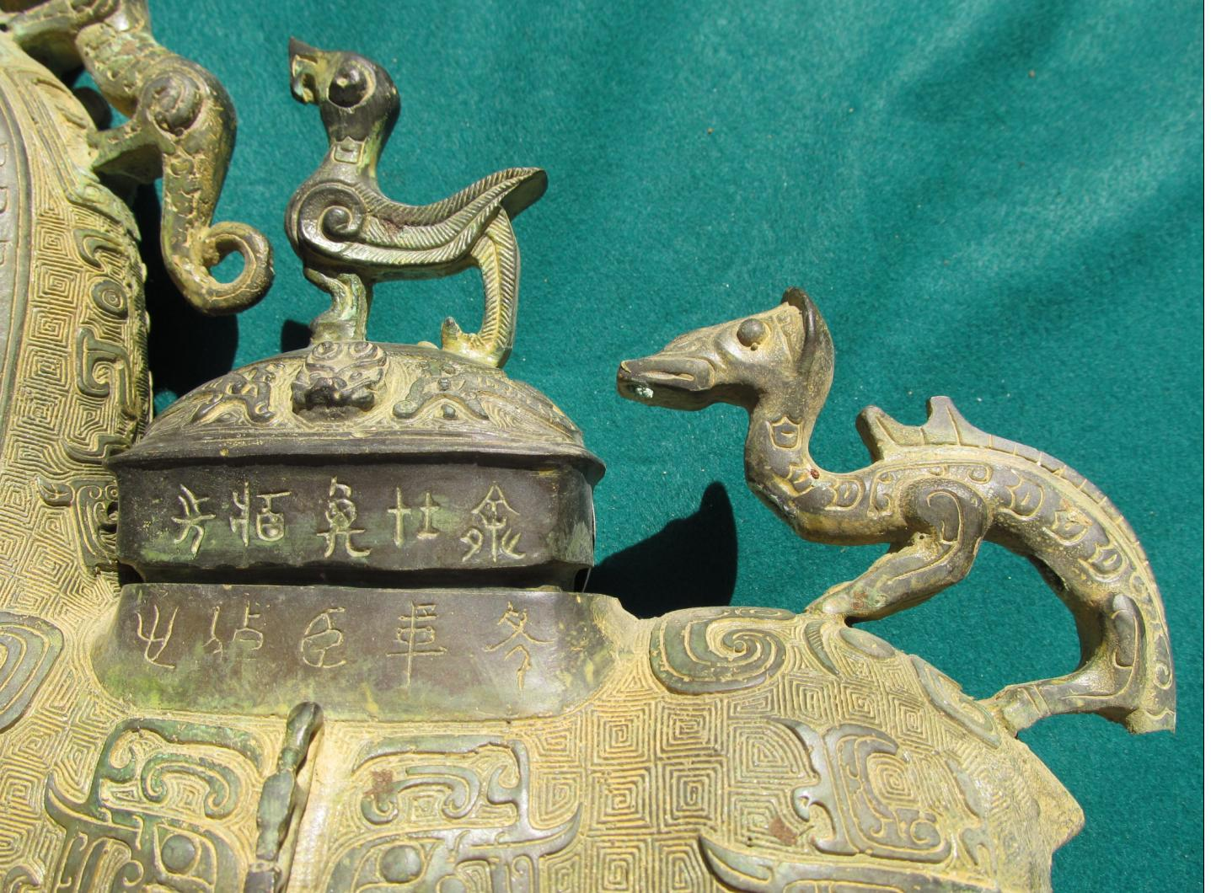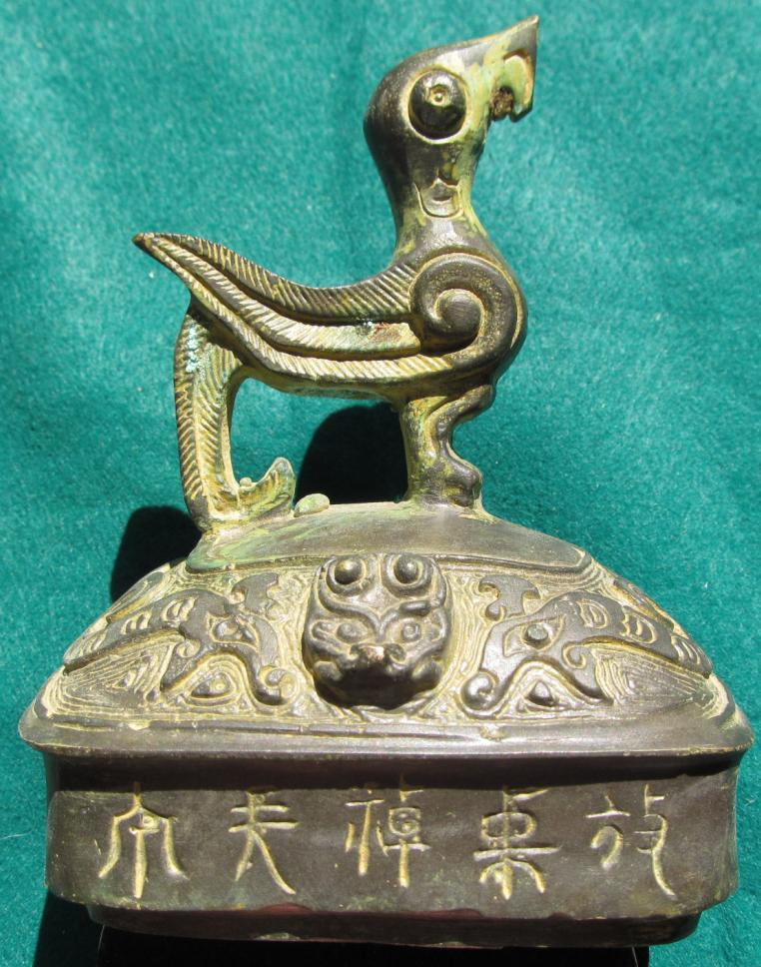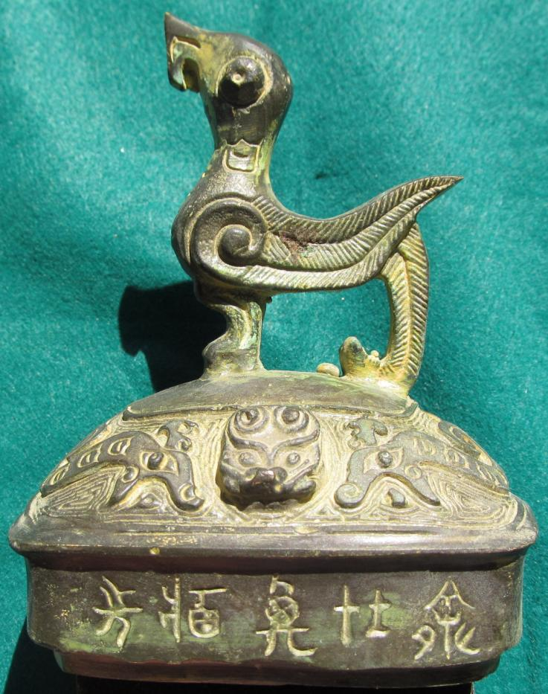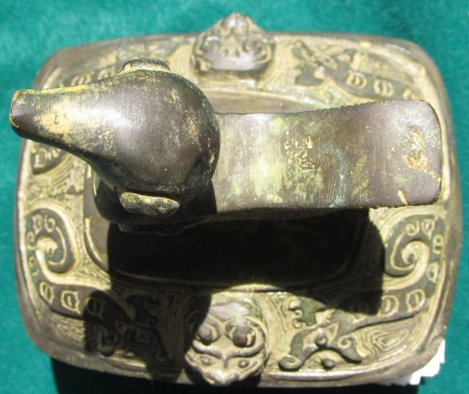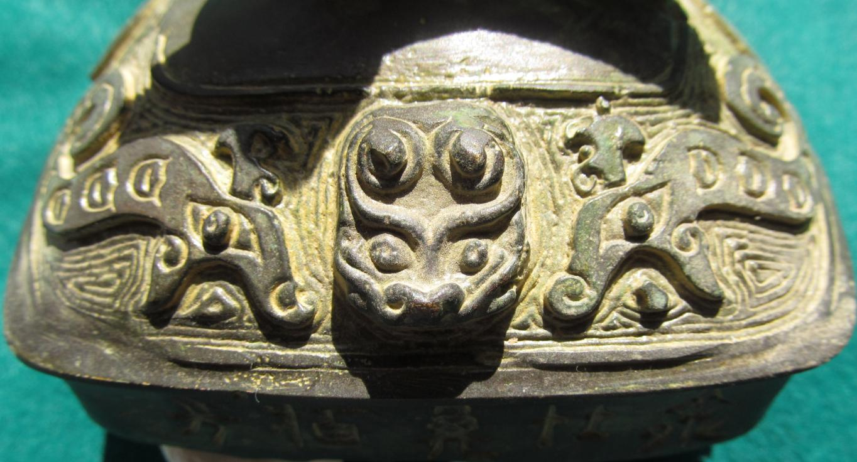

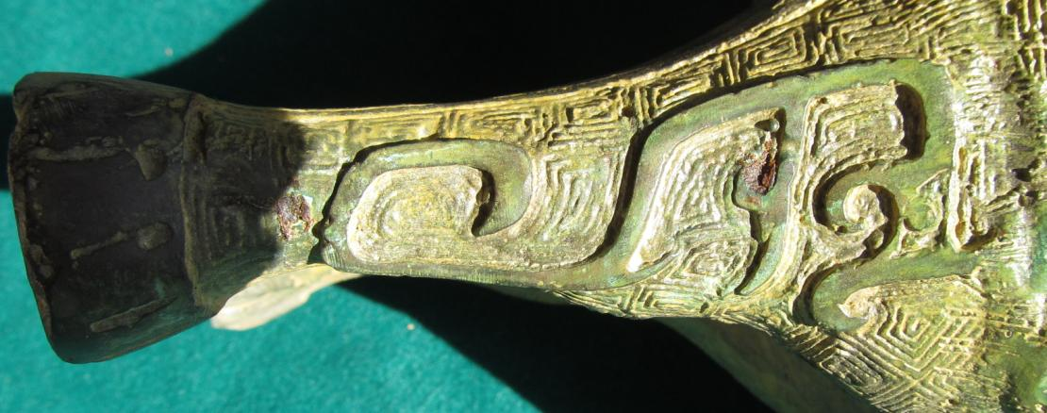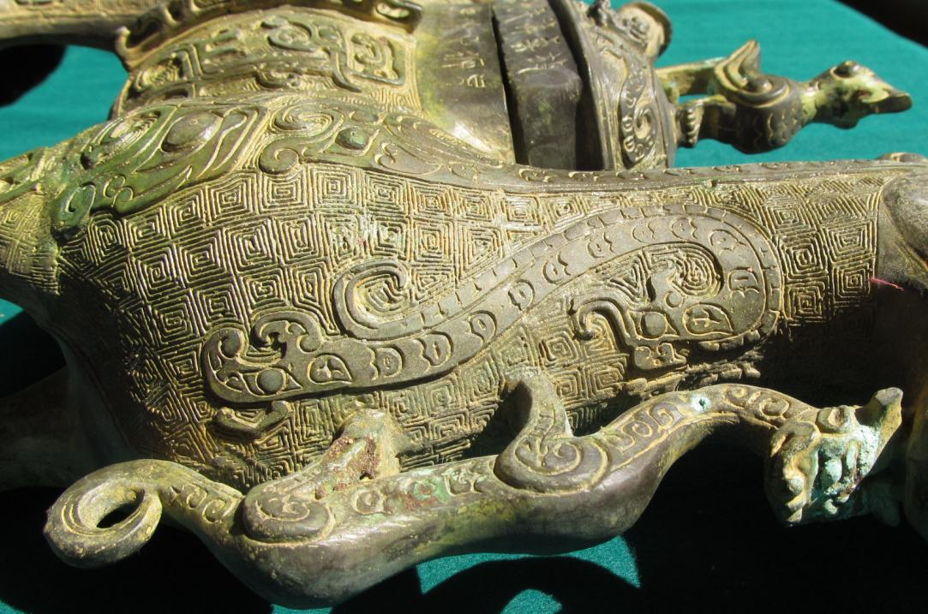

China-Shang-Guang-Camel-Muntjak-c 1200 BCE

**Case No.: 5**

**Accession No.**

**Formal Label:** China-Shang-Guang-Camel-Muntjak-c 1200 BCE

**Display Description:**

**LC Classification:**

**Date or Time Horizon: 1200 BCE**

**Geographical Area:**

**Map:**

**GPS coordinates:**

**Cultural Affiliation:**

**Media:**

**Dimensions:**

**Weight:**

**Condition:**

**Provenance:**

**Discussion:**

**This camel image is similar to the** Desert Masileh Qom. After https://media-cdn.tripadvisor.com/media/photo-s/08/e6/ac/71/autre-tunisie-day-tours.jpg

.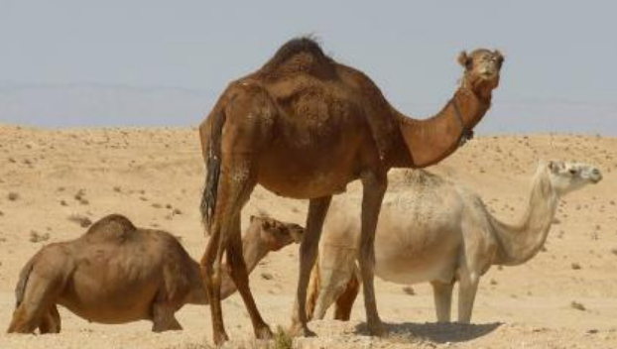

**References:**